WEEK - 6 :- React

TASK -1

App.js
function App() {
return (
<div>
<h1>Welcome to the first session of React</h1>
</div>
);
}

export default App;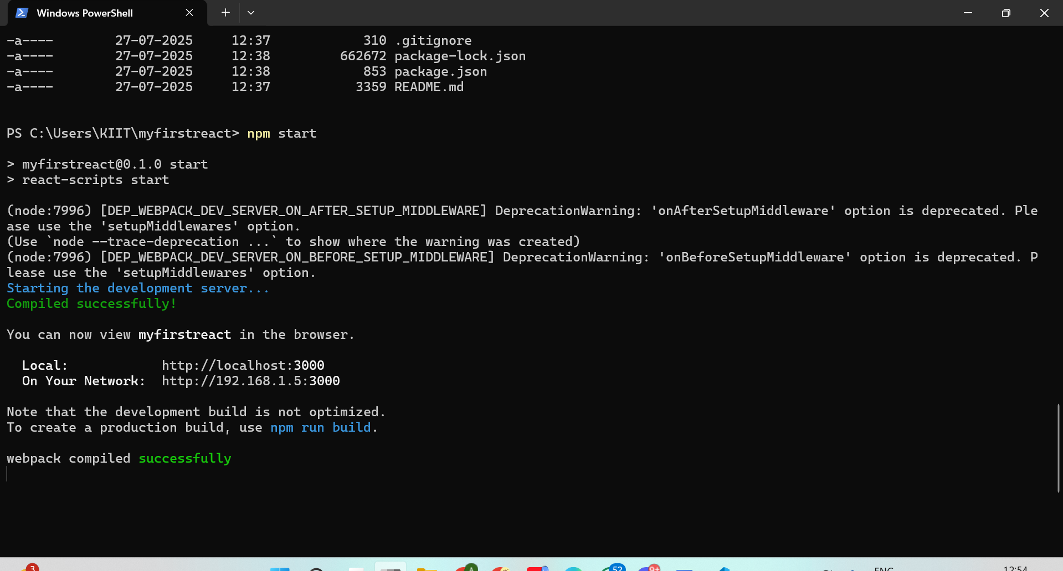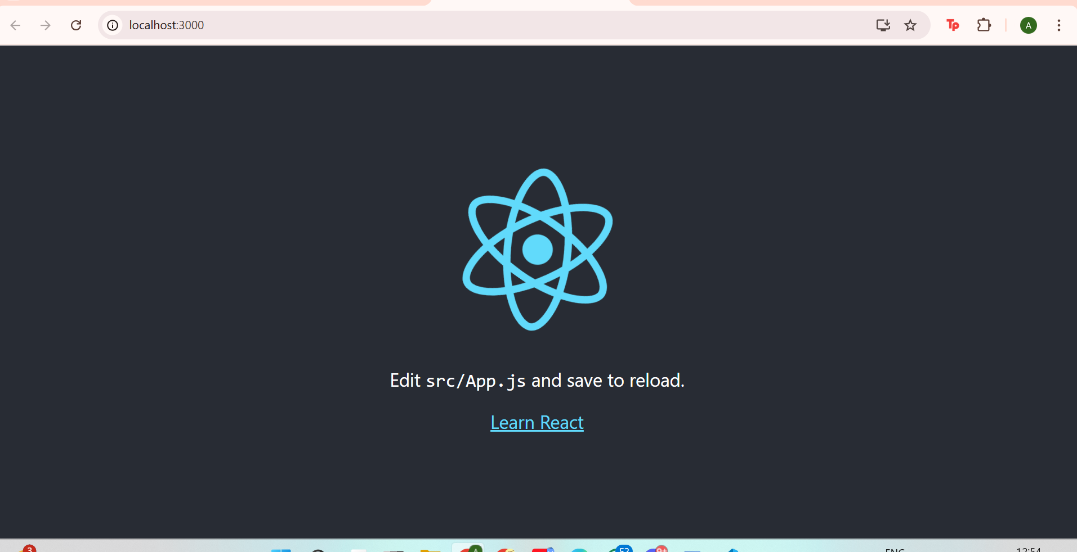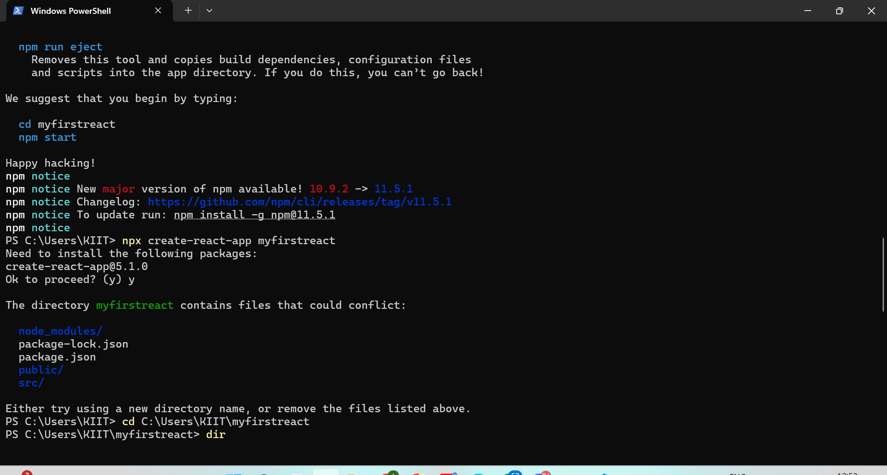
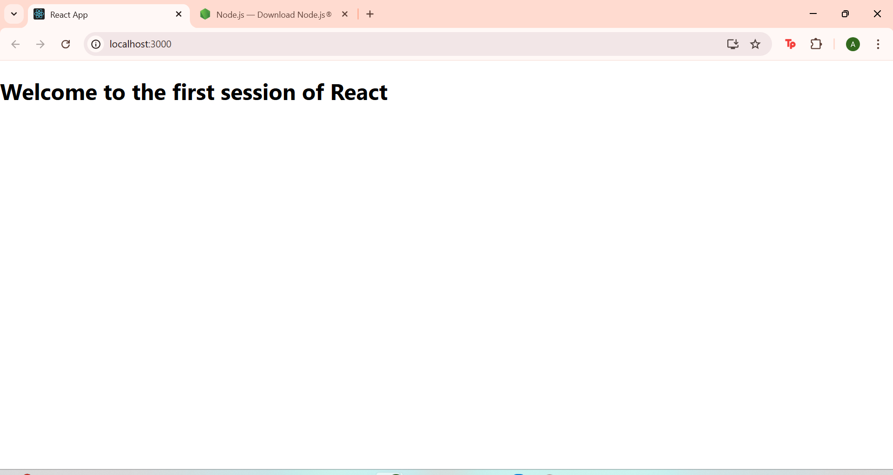

TASK-2

📄 1. src/App.js
jsx
CopyEdit
import React from 'react';import Home from './Components/Home';import About from './Components/About';import Contact from './Components/Contact';
function App() {
return (
<div>
<Home />
<About />
<Contact />
</div>
);
}
export default App;

📄 2. src/Components/Home.js
jsx
CopyEdit
import React from 'react';
function Home() {
return (
<div>
<h2>Welcome to the Home page of Student Management Portal</h2>
</div>
);
}
export default Home;

📄 3. src/Components/About.js
jsx
CopyEdit
import React from 'react';
function About() {
return (
<div>
<h2>Welcome to the About page of Student Management Portal</h2>
</div>
);
}
export default About;

📄 4. src/Components/Contact.js
jsx
CopyEdit
import React from 'react';
function Contact() {
return (
<div>
<h2>Welcome to the Contact page of Student Management Portal</h2>
</div>
);
}
export default Contact;

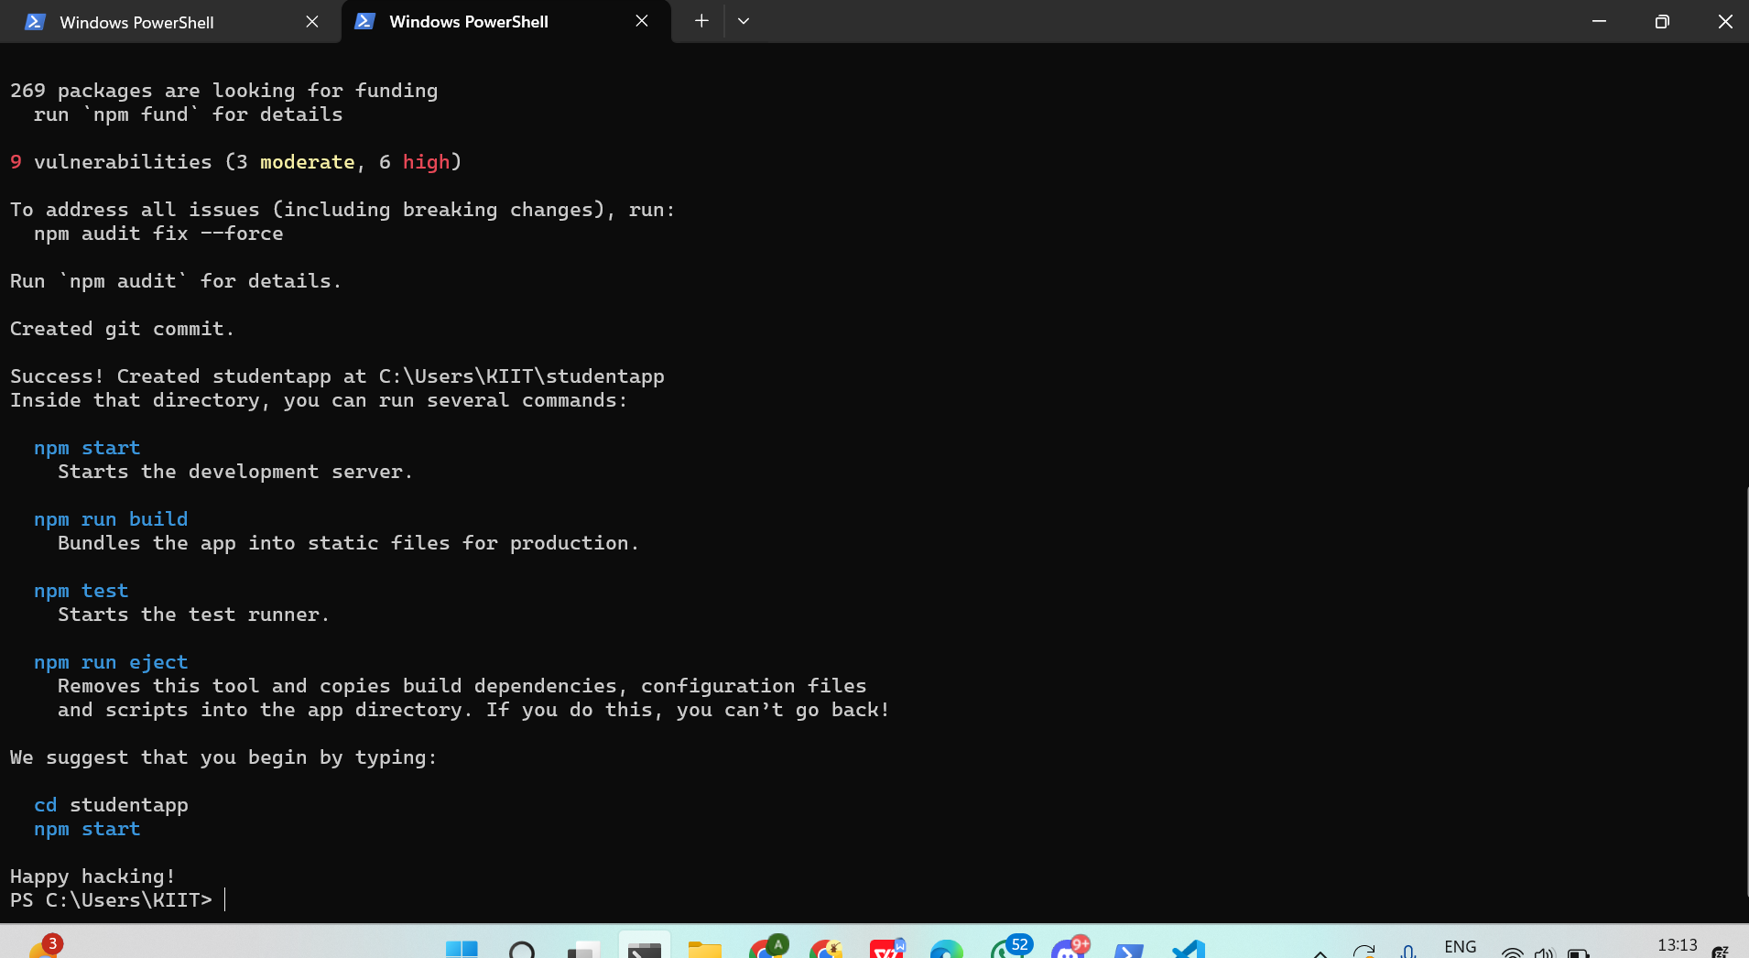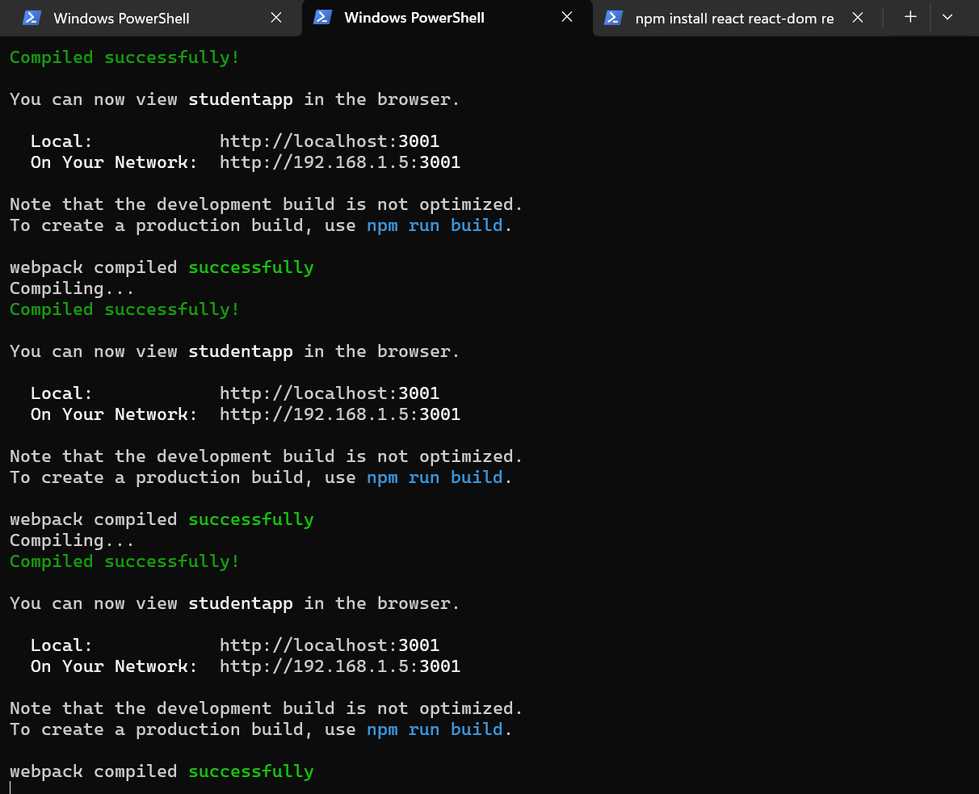
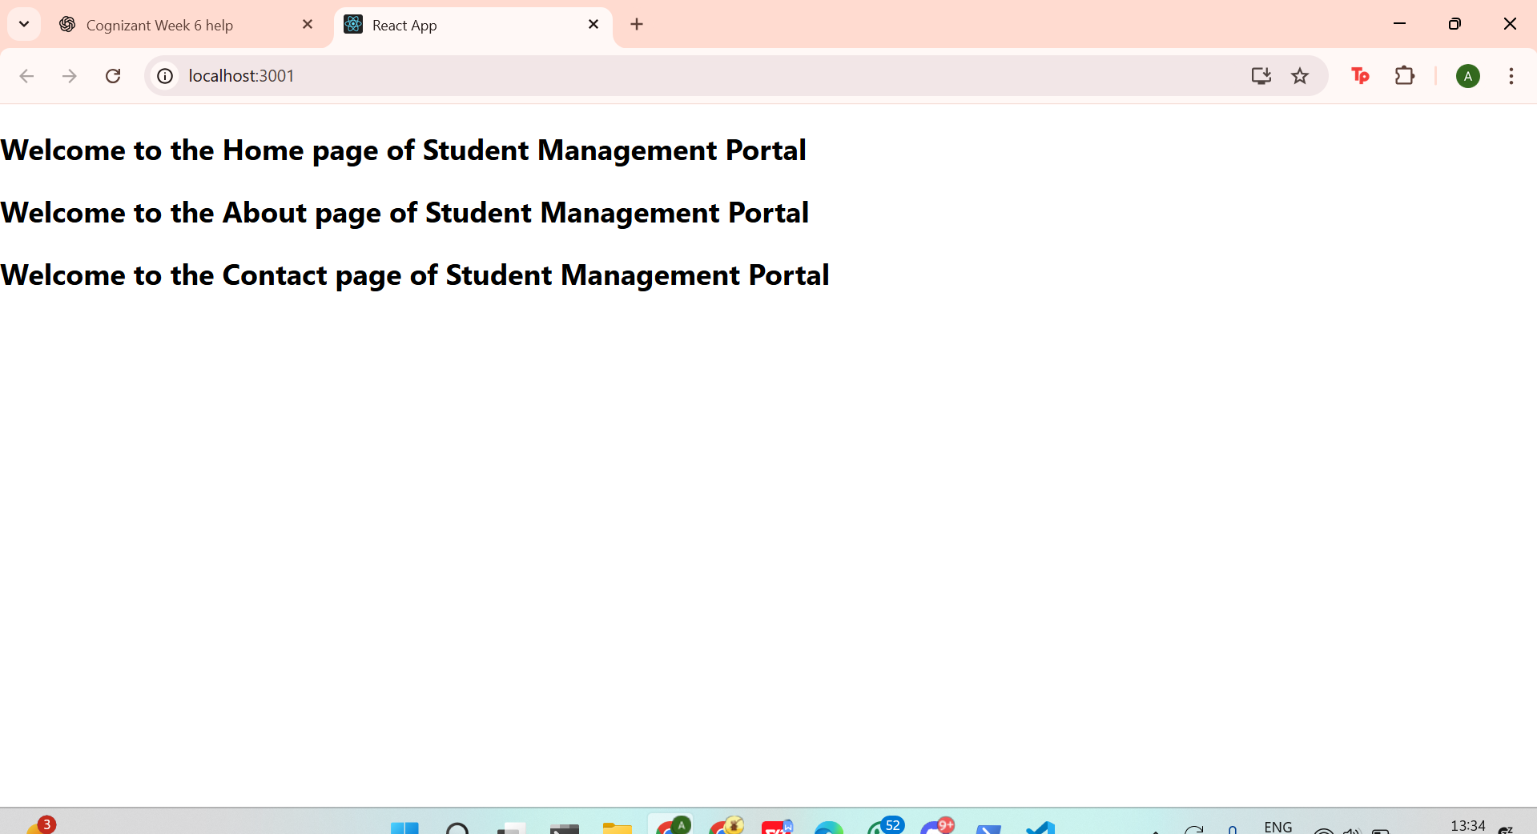
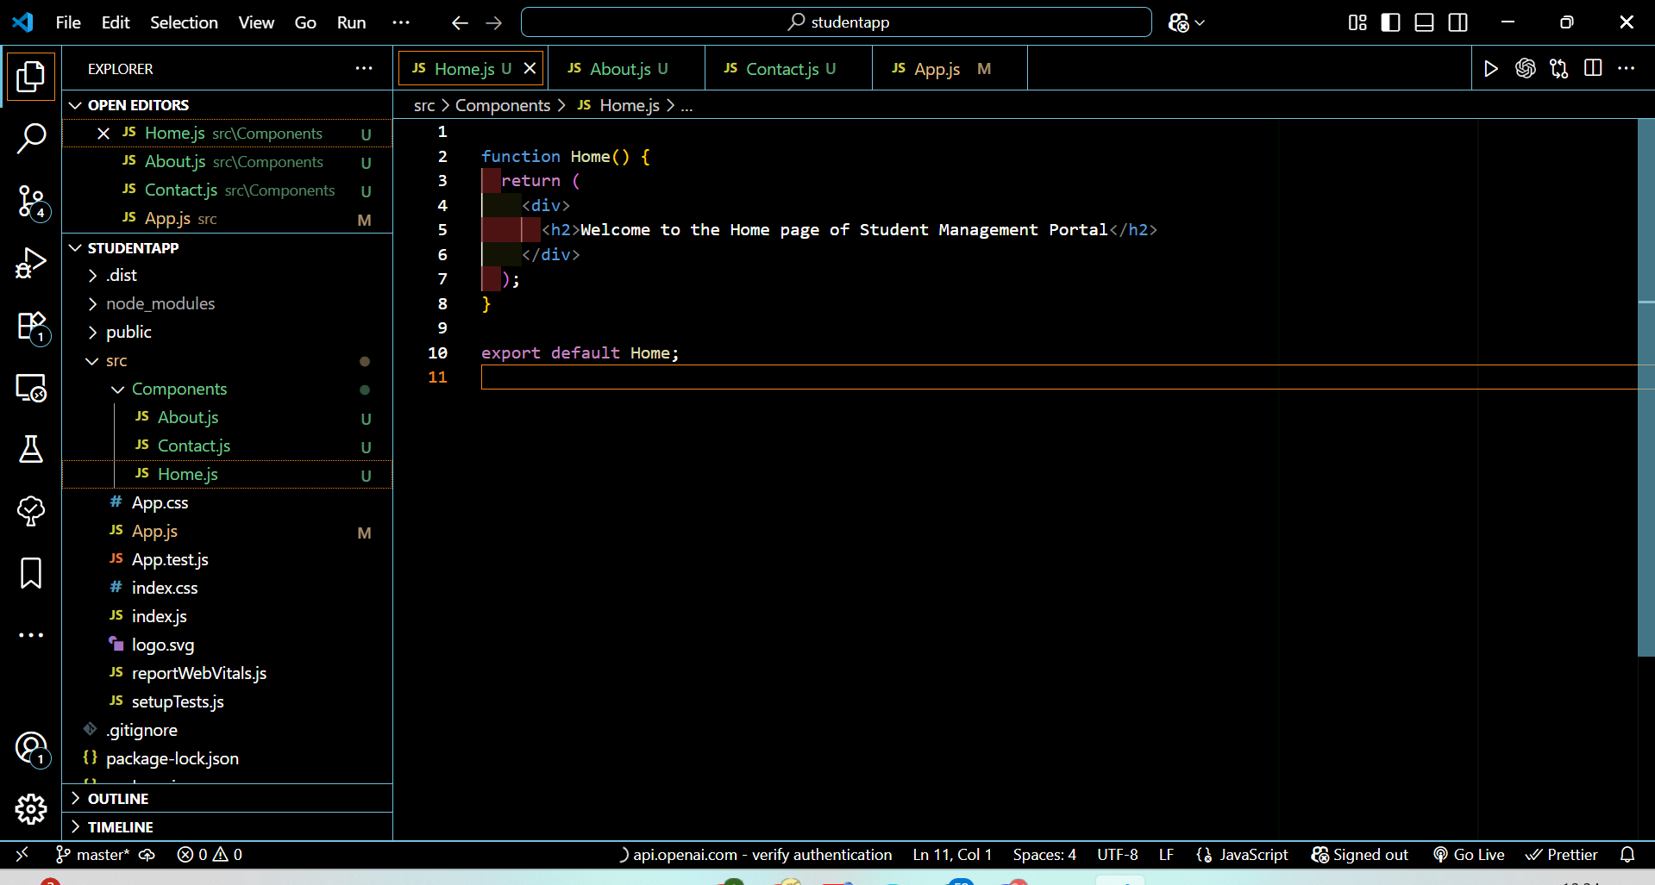

TASK-3

Folder Structure
css
CopyEdit
scorecalculatorapp/
└── src/
├── App.js
├── index.js
├── Components/
│ └── CalculateScore.js
└── Stylesheets/
└── mystyle.css

1. src/Components/CalculateScore.js
jsx
CopyEdit
import React, { useState } from 'react';import '../Stylesheets/mystyle.css';
function CalculateScore() {
const [name, setName] = useState('');
const [school, setSchool] = useState('');
const [total, setTotal] = useState('');
const [goal, setGoal] = useState('');
const [percentage, setPercentage] = useState(null);

const calculate = () => {
if (total && goal && parseFloat(goal) !== 0) {
const percent = ((parseFloat(total) / parseFloat(goal)) * 100).toFixed(2);
setPercentage(percent);
} else {
setPercentage("Invalid input");
}
};

return (
<div className="score-box">
<h2>Student Score Calculator</h2>

<input
type="text"
placeholder="Name"
value={name}
onChange={(e) => setName(e.target.value)}
/>
<input
type="text"
placeholder="School"
value={school}
onChange={(e) => setSchool(e.target.value)}
/>
<input
type="number"
placeholder="Total Marks"
value={total}
onChange={(e) => setTotal(e.target.value)}
/>
<input
type="number"
placeholder="Goal Marks"
value={goal}
onChange={(e) => setGoal(e.target.value)}
/>

<button onClick={calculate}>Calculate Percentage</button>

{percentage && (
<div className="result">
<p><strong>Name:</strong> {name}</p>
<p><strong>School:</strong> {school}</p>
<p><strong>Percentage:</strong> {percentage}%</p>
</div>
)}
</div>
);
}
export default CalculateScore;

2. src/Stylesheets/mystyle.css
css
CopyEdit
.score-box {
width: 400px;
margin: 40px auto;
padding: 20px;
border: 2px solid #ddd;
border-radius: 10px;
background-color: #f0f8ff;
text-align: center;
font-family: Arial, sans-serif;
}
.score-box h2 {
margin-bottom: 20px;
color: #333;
}
.score-box input {
display: block;
width: 90%;
padding: 8px;
margin: 10px auto;
border-radius: 6px;
border: 1px solid #ccc;
}
.score-box button {
padding: 10px 20px;
border: none;
border-radius: 6px;
background-color: #4caf50;
color: white;
font-weight: bold;
cursor: pointer;
margin-top: 10px;
}
.result {
margin-top: 20px;
background-color: #e8ffe8;
padding: 10px;
border-radius: 6px;
}

3. src/App.js
jsx
CopyEdit
import React from 'react';import CalculateScore from './Components/CalculateScore';
function App() {
return (
<div>
<CalculateScore />
</div>
);
}
export default App;

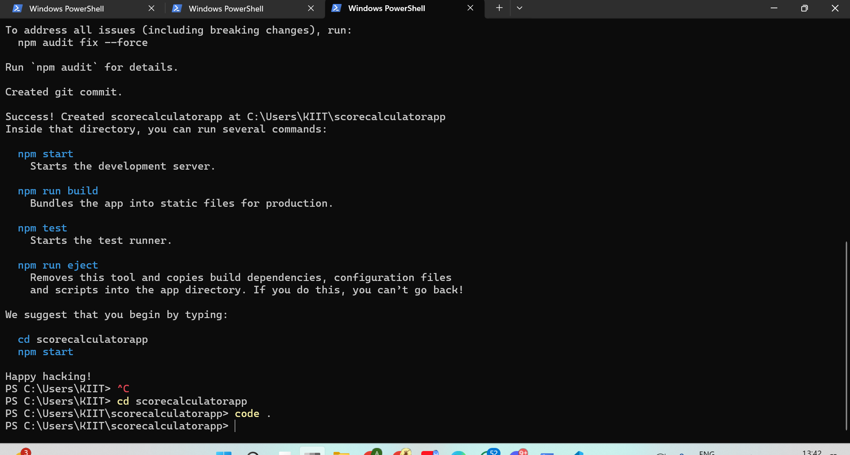
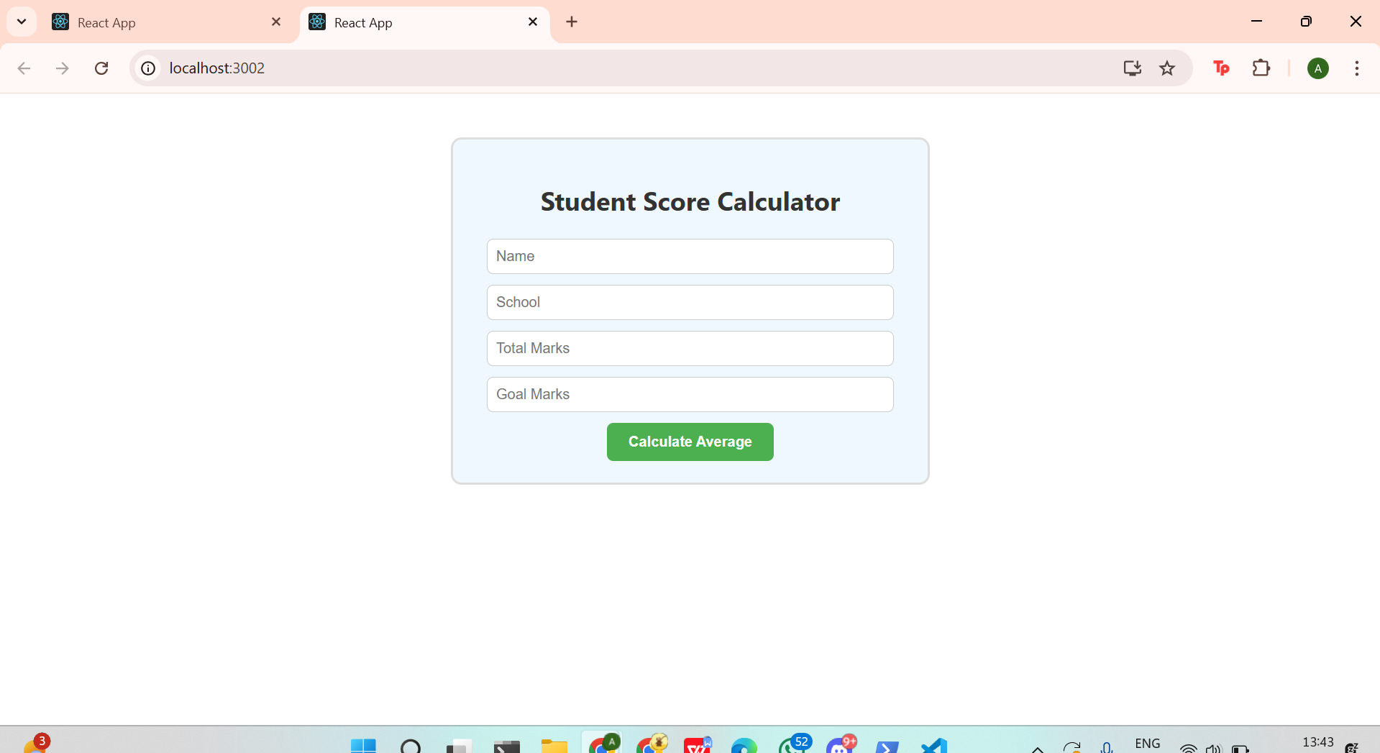
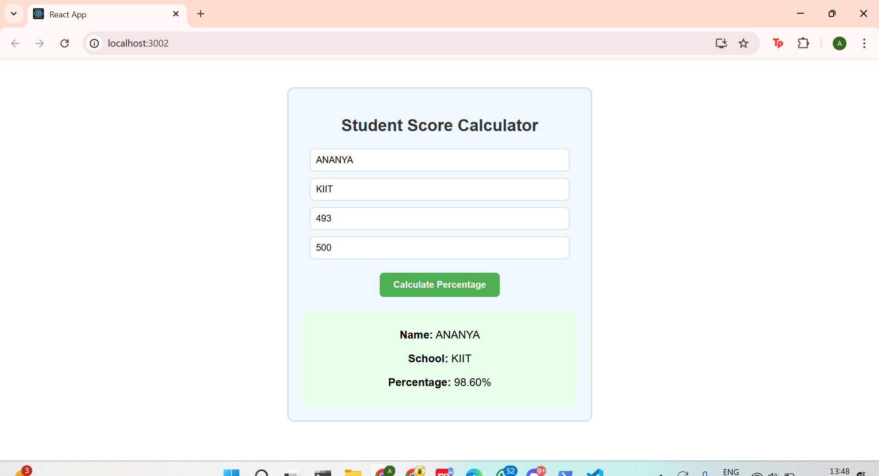

TASK 4

1.Folder Structure (inside src/)
css
CopyEdit
src/
├── App.js
├── Posts.js
└── Post.js

2. src/Post.js – (individual blog post)
jsx
CopyEdit
import React from 'react';
function Post({ title, body }) {
return (
<div style={{ border: '1px solid #ccc', margin: '10px', padding: '15px', borderRadius: '10px' }}>
<h3>{title}</h3>
<p>{body}</p>
</div>
);
}
export default Post;

3. src/Posts.js – (class component that fetches + renders)
jsx
CopyEdit
import React, { Component } from 'react';import Post from './Post';
class Posts extends Component {
constructor(props) {
super(props);
this.state = {
posts: [],
hasError: false
};
}

componentDidMount() {
this.loadPosts();
}

loadPosts() {
fetch('https://jsonplaceholder.typicode.com/posts')
.then((response) => response.json())
.then((data) => {
this.setState({ posts: data.slice(0, 5) }); // Limiting to 5 posts for simplicity
})
.catch((error) => {
console.error('Error fetching posts:', error);
this.setState({ hasError: true });
});
}

componentDidCatch(error, info) {
console.error('Component Error:', error, info);
alert('Something went wrong while rendering posts.');
this.setState({ hasError: true });
}

render() {
if (this.state.hasError) {
return <h2 style={{ color: 'red' }}>Oops! Something went wrong while loading posts.</h2>;
}

return (
<div>
<h2>Latest Blog Posts</h2>
{this.state.posts.map((post) => (
<Post key={post.id} title={post.title} body={post.body} />
))}
</div>
);
}
}
export default Posts;

4. src/App.js
jsx
CopyEdit
import React from 'react';import Posts from './Posts';
function App() {
return (
<div style={{ padding: '20px', fontFamily: 'Arial' }}>
<h1>BlogApp – Powered by React Class Components</h1>
<Posts />
</div>
);
}
export default App;
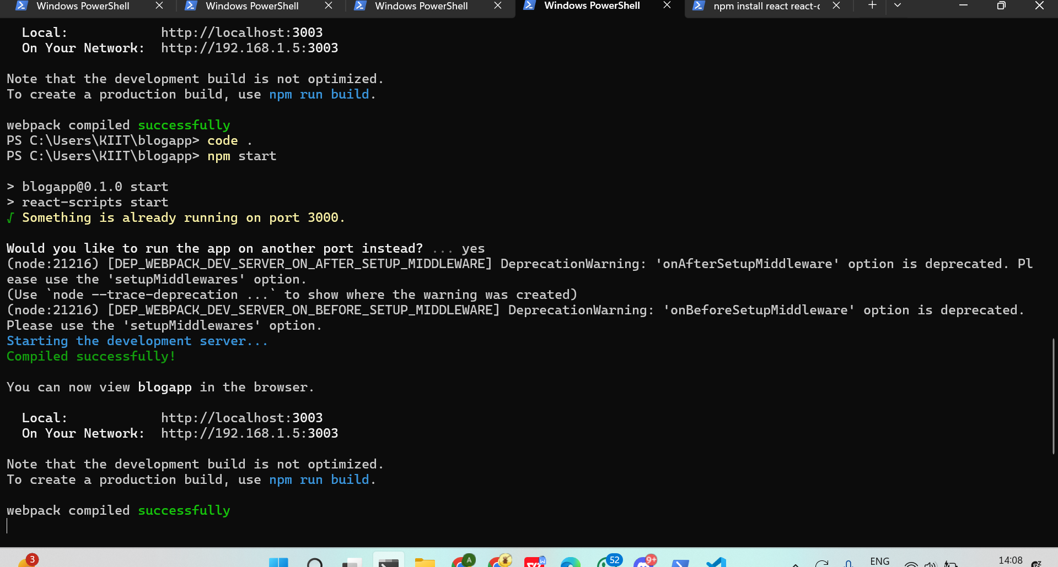
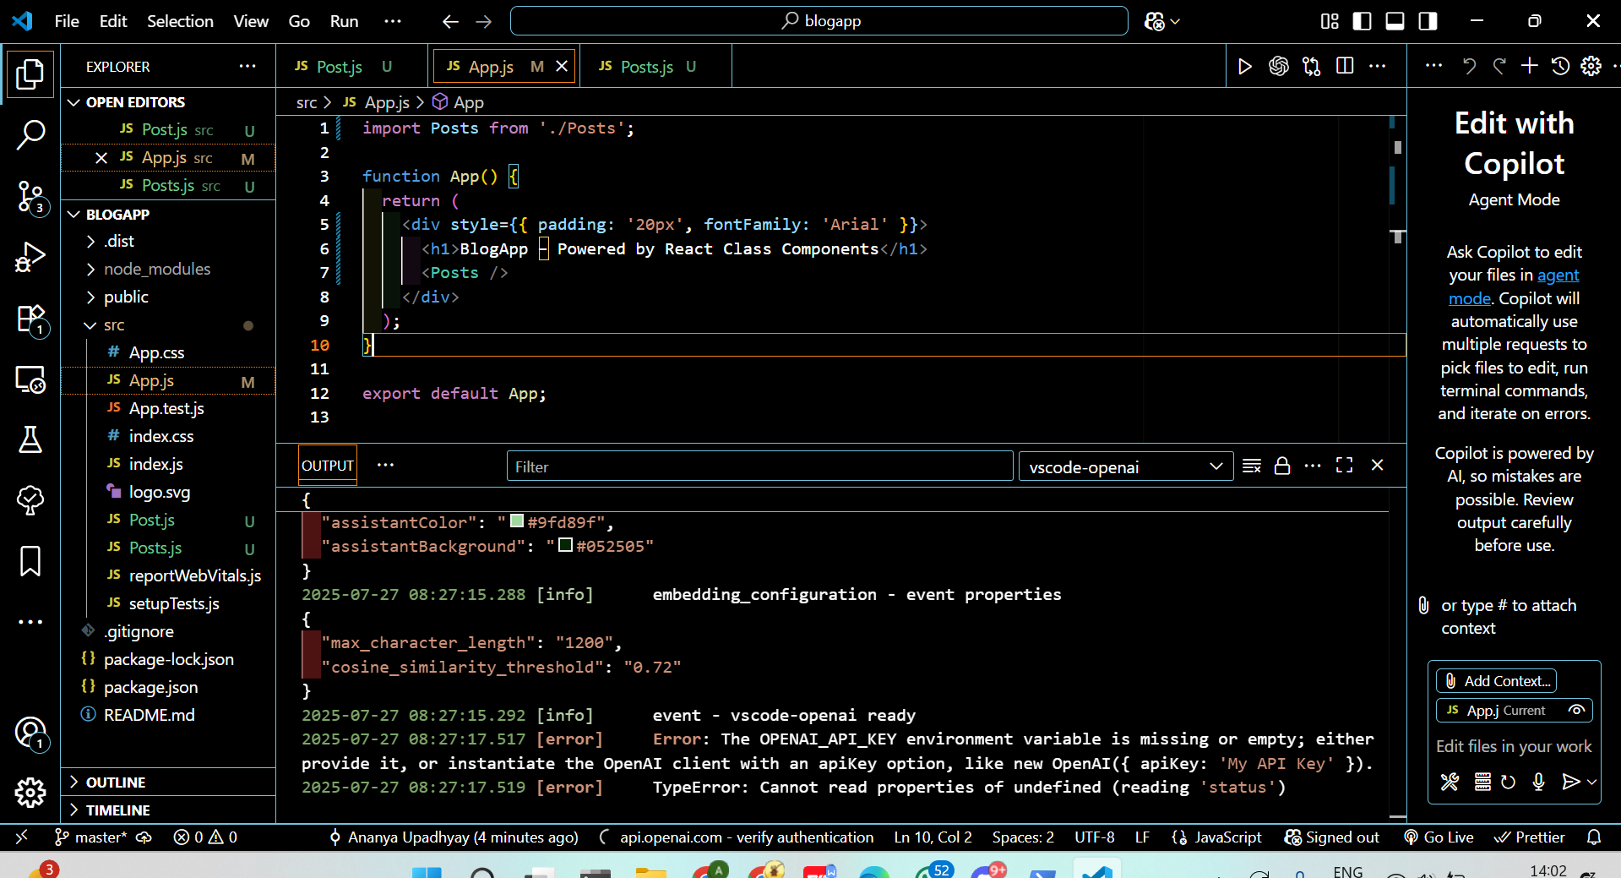
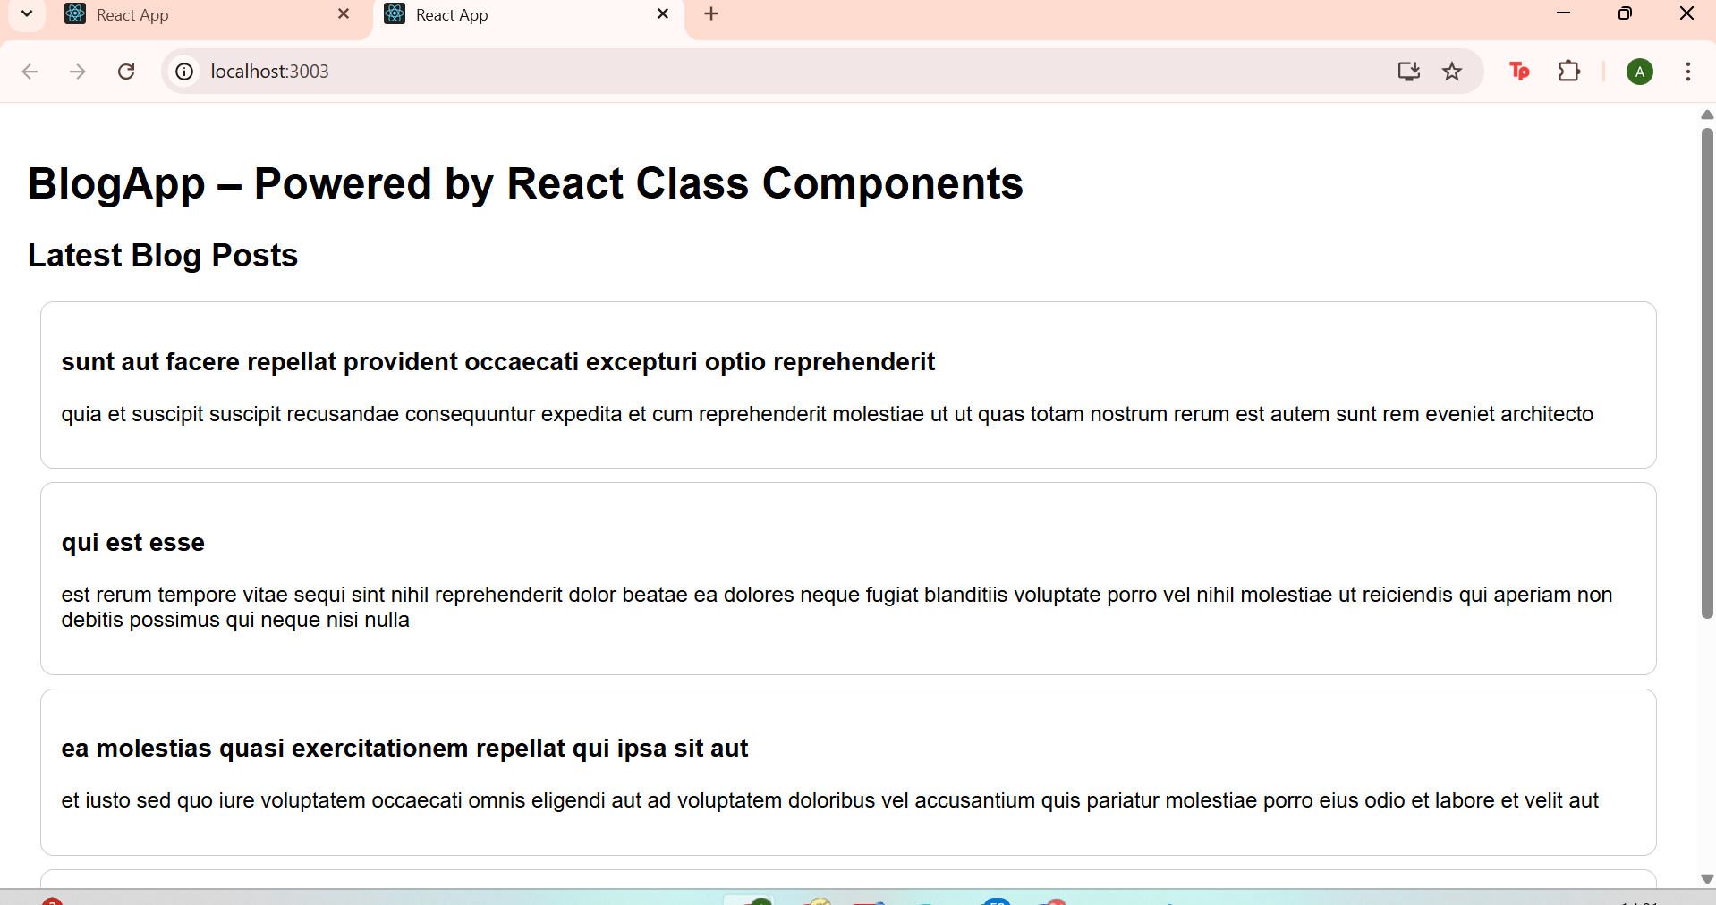

TASK-5

Folder Structure:
cpp
CopyEdit
src/
├── App.js
├── Components/
│ └── CohortDetails.js
└── Styles/
└── CohortDetails.module.css

1. src/Components/CohortDetails.js
jsx
CopyEdit
import React from 'react';import styles from '../Styles/CohortDetails.module.css';
function CohortDetails({ cohort }) {
const { name, status, startDate, endDate } = cohort;

const titleStyle = {
color: status.toLowerCase() === 'ongoing' ? 'green' : 'blue',
};

return (
<div className={styles.box}>
<h3 style={titleStyle}>{name}</h3>
<dl>
<dt>Status:</dt>
<dd>{status}</dd>
<dt>Start Date:</dt>
<dd>{startDate}</dd>
<dt>End Date:</dt>
<dd>{endDate}</dd>
</dl>
</div>
);
}
export default CohortDetails;

2. src/Styles/CohortDetails.module.css
css
CopyEdit
.box {
width: 300px;
display: inline-block;
margin: 10px;
padding: 10px 20px;
border: 1px solid black;
border-radius: 10px;
background-color: #f9f9f9;
font-family: Arial, sans-serif;
}
dt {
font-weight: 500;
}

3. src/App.js
jsx
CopyEdit
import React from 'react';import CohortDetails from './Components/CohortDetails';
function App() {
const cohorts = [
{
name: 'React Ninja Cohort',
status: 'ongoing',
startDate: '2025-06-01',
endDate: '2025-09-30',
},
{
name: 'Fullstack Jedi Cohort',
status: 'completed',
startDate: '2025-01-01',
endDate: '2025-04-30',
},
{
name: 'Cloud Witches Cohort',
status: 'ongoing',
startDate: '2025-07-01',
endDate: '2025-10-31',
},
];

return (
<div style={{ padding: '20px' }}>
<h1>Cohort Dashboard</h1>
{cohorts.map((cohort, index) => (
<CohortDetails key={index} cohort={cohort} />
))}
</div>
);
}
export default App;

